**KAMARAJ COLLEGE,TUTICORIN**

**DEPARTMENT OF PHYSICS**

**PROJECT REPORT TEMPLATE**

**TITLE :**

**ANALYSING HOUSING PRICES IN METROPOLITAN AREAS OF INDIA**

**TEAM MEMBERS :**

* **M.PAVITHRA**
* **A.PETCHIMUTHU**
* **M.SURESH RAJA**
* **L.MOOKKAMMAL**

**INTRODUCTION :**

**1.1:OVERVIEW :**

* **OUR PROJECT IS ABOUT ANALYSING HOUSING PRICES IN METROPOLITAN AREAS IN INDIA.**
* **HOUSE PRICE PREDICTIONS ARE BENEFICIAL FOR PROPERTY INVESTORS TO KNOW THE TREND OF HOUSING PRICES IN A CERTAIN LOCATIONS.**

**1.2: PURPOSE :**

* **HOUSING PRICE PREDICTION HELPS PEOPLE WHO PLAN TO BUY A HOUSE SO THAT THEY CAN KNOW THE PRICE RANGE IN THE FUTURE , THEN THEY CAN PLAN THEIR FINANCE WELL.**

**PROBLEM DEFINITION & DESIGN THINKING :**

**2.1: EMPATHY MAP :**

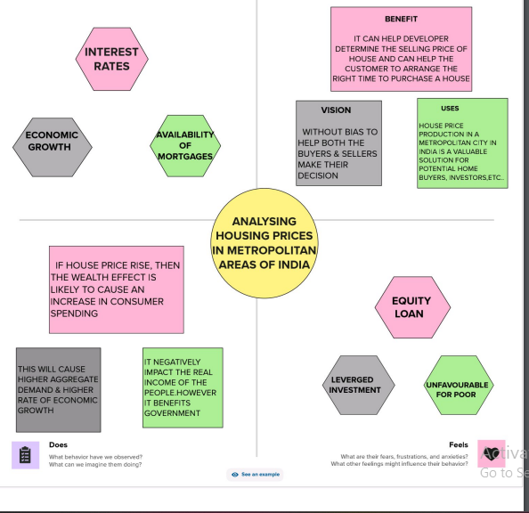

**2.2:IDEATION AND BRAINSTORMING MAP :**

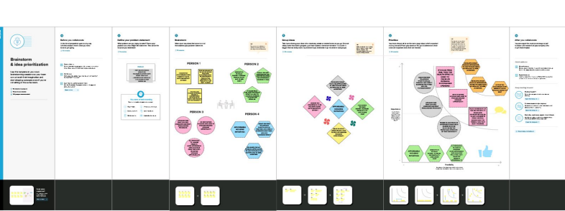

**RESULT :**

**    **

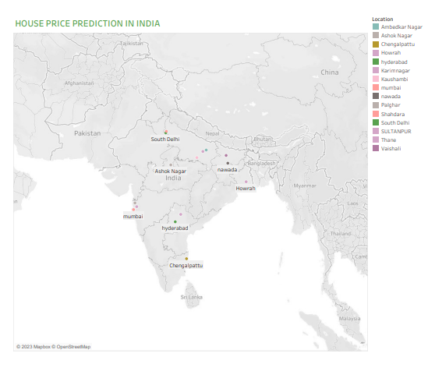

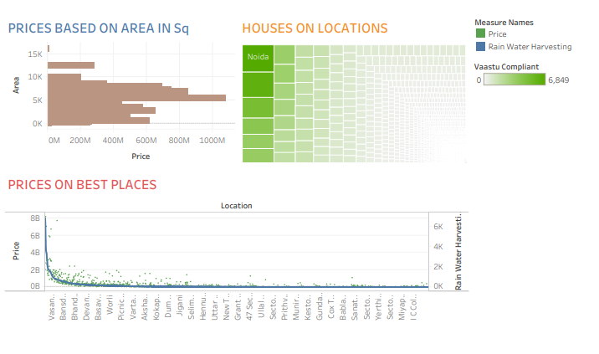

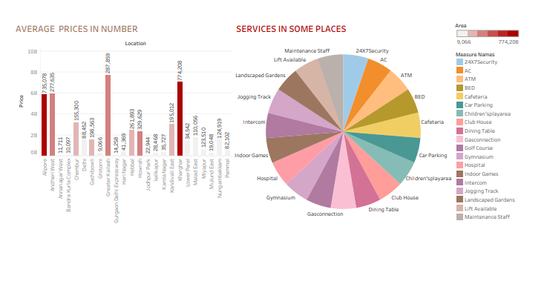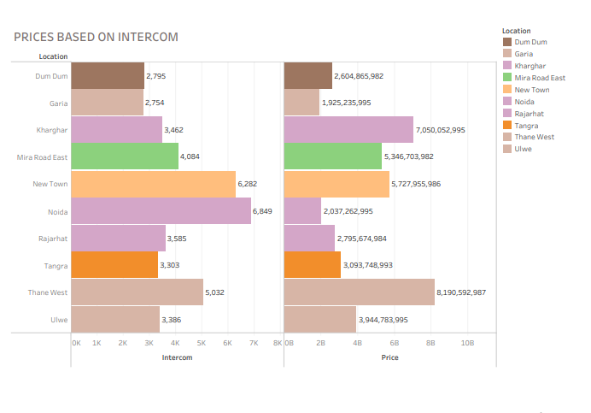

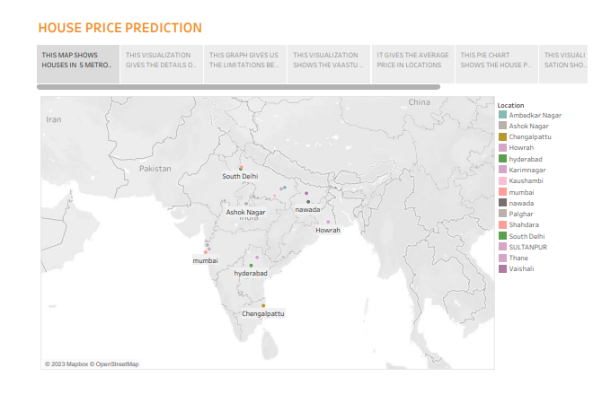

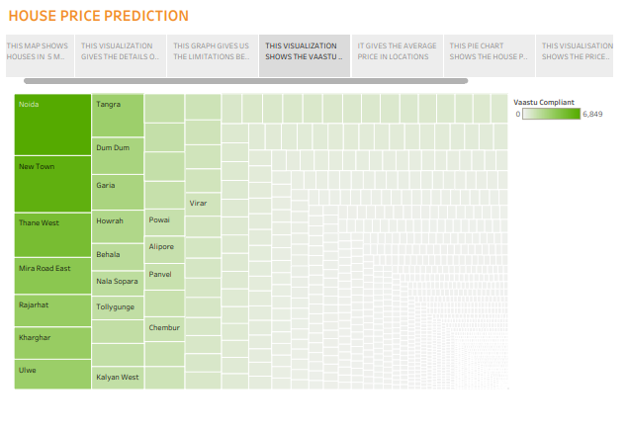

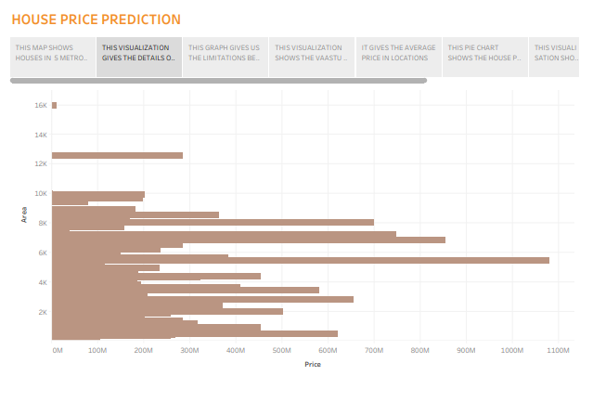

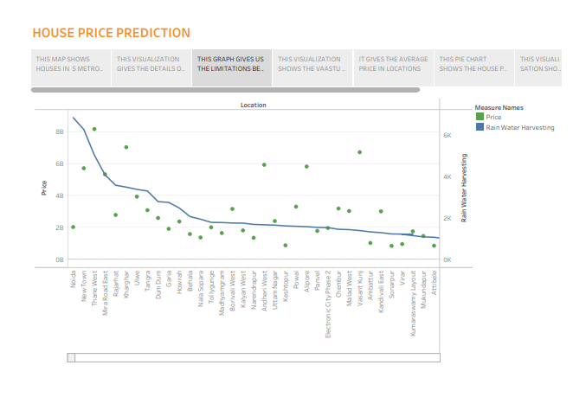 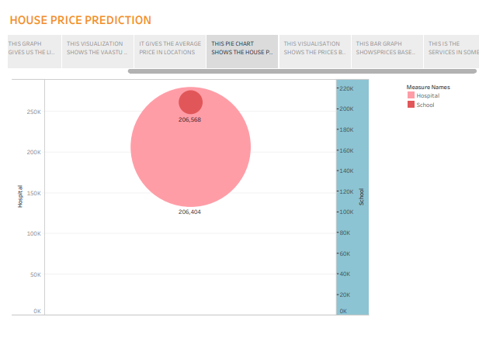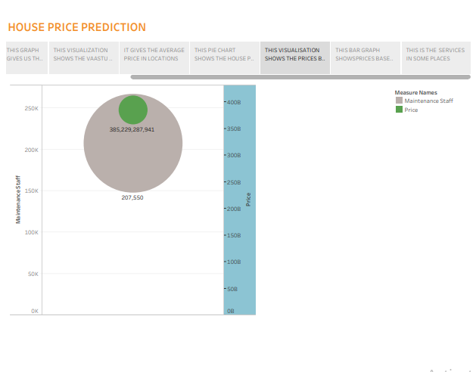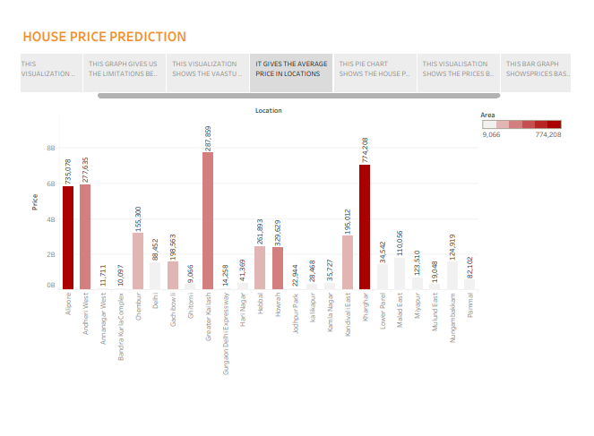

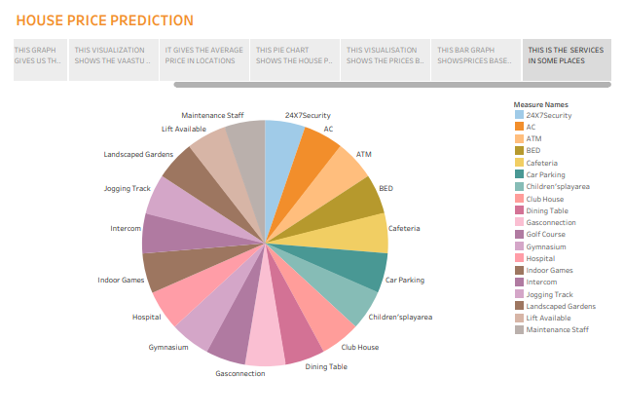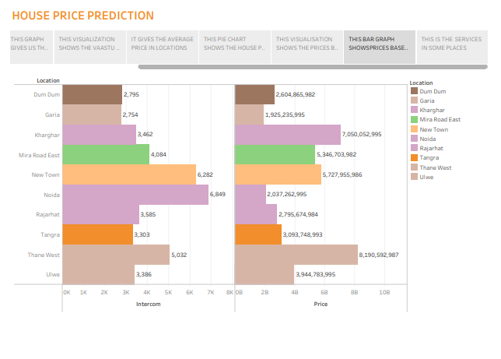

**ADVANTAGES AND DISADVANTAGES :**

**ADVANTAGES :**

* **WITHOUT BIAS HELP BOTH THE BUYERS AND SELLERS TO MAKE THEIR DECISIONS**
* **IT CAN HELP DEVELOPERS TO DETERMINE THE SELLING PRICE OF HOUSE**

**DISADVANTAGES :**

* **UNFAVOURABLE FOR POOR**
* **IF HOUSING PRICE RISE THEN THE WEALTH EFFECT IS LIKELY TO INCREASE IN CONSUMER DEMANDING**

**APPLICATIONS :**

* **IT HELP THE DEVELOPER DETERMINE THE SELLING PRICE OF A HOUSE**
* **IT ALSO HELPS THE CUSTOMER TO ARRANGE THE RIGHT TIME TO PURCHASE A HOUSE**

**CONCLUSION :**

* **IT IS ABLE TO PREDICT HOUSE PRICE AROUND 90%ACCURACY FOR MOST THE CASES**
* **THE MACHINE LEARNING MODEL USING LINEAR REGRESSION ALGORITHM IS VERY HELPFUL IN PREDICTING THE HOUSE PRICES**

**FUTURE SCOPE :**

* **HOUSE PRICE PREDICTION IS IMPORTANT TO DRIVE REAL ESTATE EFFICIENCY**
* **PROPERTY PRICES IN INDIA ARE EXPECTED TO INCREASE 7.5%**
* **AVERAGE HOUSE PRICES WERE FORECAST TO RISE 6% IN 2024**